Welcome!
Date
Name
Spouse
Address
City
State Zip _________
Email

Please Contact By
❑ Card  Phone  Visit

Telephone Best Time to Call
Home ______________
Work ______________

Guest: First Time Second Time
Are you a church member: yes no
Church
City, State

Circle Appropriate Age/Grade Group(s)
Preschool: Ages: B-1 2-3 4-5
Children: Grades: K 1 2 3 4 5 6
Youth: Grades: 7 8 9 10 11 12
Adults: Ages:18-29 30s 40s 50s 60s+

How did you learn about our church?
Newspaper Friend Yellow Pages Mail
Other

I am a guest of:

New in the Community? Yes No
Names & ages of children at home

Weekly Service & Activity Schedule

August 23, 2015

9:45 a.m. Sunday School
11:00 a.m. Worship Service
6:00 p.m. Evening Worship Service
Week of August 23, 2015
Wednesday 7:00 pm Adult Bible Study
Thursday 10:00 am Adult Fellowship

Upcoming Events
August
30………..…………Baby Shower for Ashley Smothermon
September
5…………….....……80th Birthday Party for Cleyon Davis
10……………………………………………Adult Fellowship
12…………..…..Living Proof Live Simulcast FBC Rogers
13……………………………..……………Business Meeting
13-19……….Week of Prayer – Mary Hill Davis Missions
20……………….Operation Christmas Child Box Packing

Join us, as we celebrate Cleyon Davis’ 80th birthday!
Saturday, Sept. 5 2:00 – 4:00 in the Fellowship Hall



Sat. Sept. 12 @ FBC Rogers – Sign- up sheets on bulletin boards in Sanctuary and Sunday School hall or contact Patti Radford 512-968-7821

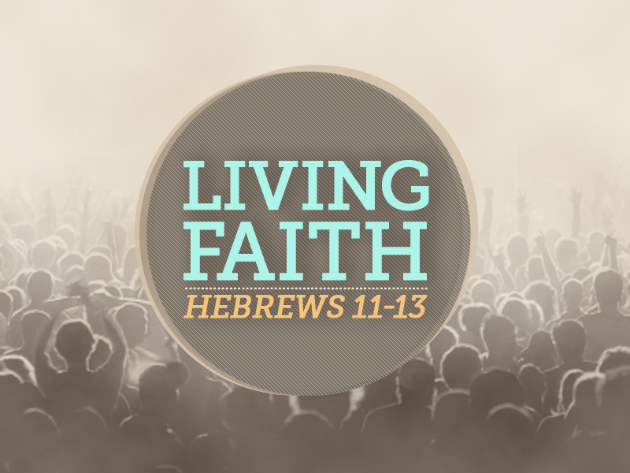

Knobbs Springs Baptist Church

August 23, 2015

Church Information:

KnobbsSpringsBC.com KnobbsSpringsBaptist@gmail.com
1662 CR 305, McDade, Texas 78650 512-273-2743

David Atwood, Pastor Cell 512-470-5098
Home 512-856-2819
Patti Radford, Office Manager Cell 512-968-7821

